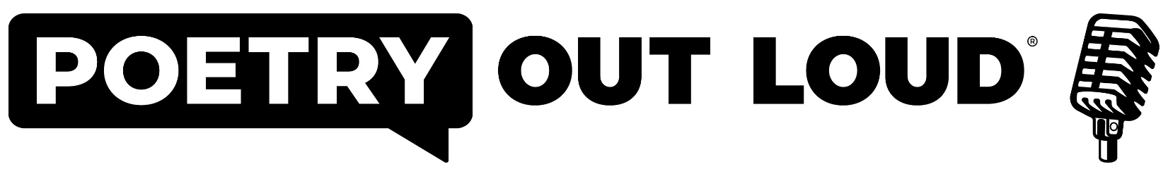Regional Poetry Out Loud Competition
School Winner Registration Form
Due January 13th, 2023

Schools should select ONE school-wide winner to represent them at the Regional Poetry Out Loud Competition to be held on Friday, January 27th at the Dunn Center for Performing Arts located in Towanda, PA.

School/District/Address __________________________________________________________________

Student Name _______________________________________ Age ________ Grade ___________

Runner-Up Name ____________________________________ Age ________ Grade ___________

Class ________________________________________________________________________________

Total # of Students Who Participated in School Contest _________ Total # of Teachers ________

Teacher(s)/Coach(es) ____________________________________________________________________

Teacher(s)/Coach(es) contact (phone & e-mail) _______________________________________________

Poem List: School winner must select three different poems for the regional competition. One poem must be 25 lines or shorter, and one poem must be pre 20th Century (the same poem can be used to satisfy both requirements, and may be the student’s third poem). Poems must come from the on-line POL anthologies. Please list poems in order they will be performed (poem order can NOT be changed after submitted to BCRAC):

- _______________________________________________________________________

- _______________________________________________________________________

- _______________________________________________________________________

Please send student registration to Renae Chamberlain at the Bradford County Regional Arts Council (email or post):
ntpaie@bcrac.org, or Bradford County Regional Arts Council - 601 Main Street - Towanda, PA 18848
