Intent to Participate in
POETRY OUT LOUD 2022-2023
Yes! We are interested in participating in
The Pennsylvania Poetry Out Loud Recitation Contest.

For an online Teacher’s Guide go to:
https://www.poetryoutloud.org/wp-content/uploads/sites/2/2022/08/POL_TG22-23_4webACCESSIBLE_8.2.22-1.pdf

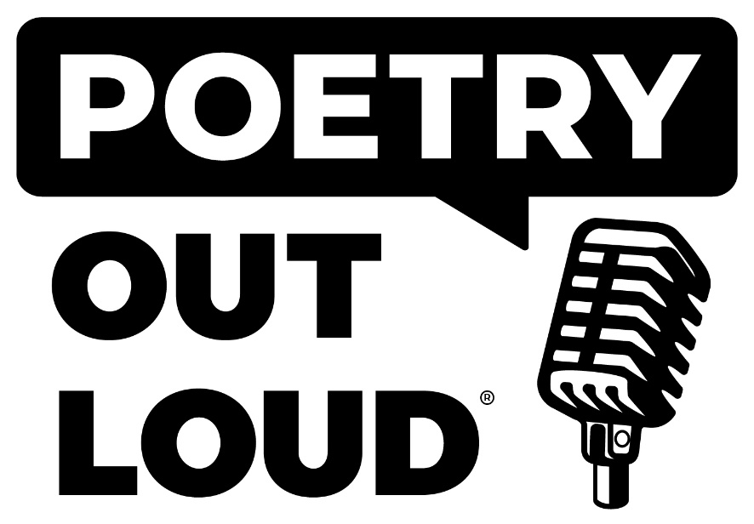

The class participating is (check all that apply):
___ Creative Writing ___ Language Arts/English ___ Theatre
___ Speech ___ Forensics Team
___ Other (please specify) _____________________________________________________

Estimated number of teachers participating _________________

Estimated number of students participating _________________

School Name ___________________________________ District ______________________________

Mailing Address __________________________________ City _______________________________

County ________________ Zip _____________ Phone _________________Fax _________________

Teachers/staff members in charge _______________________________________________________

Phone _________________________ E-mail _______________________________________________

_______________________________________
Signature of teacher/staff person in charge
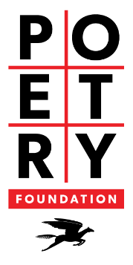
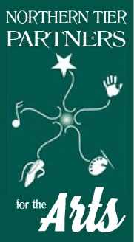
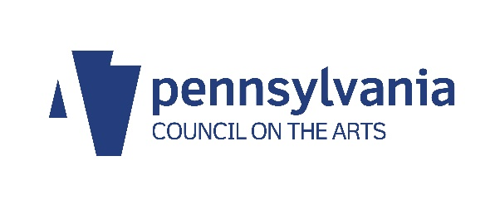
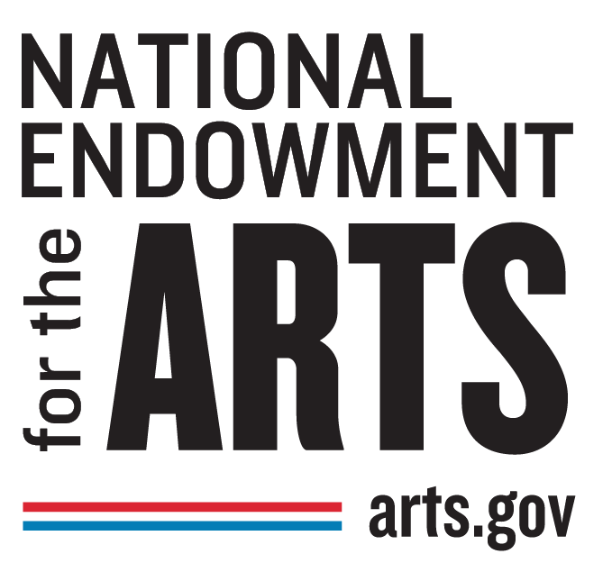
Return this form by November 18th to: Questions?
Renae Chamberlain call 570.268.2787
BCRAC/POL e-mail ntpaie@bcrac.org
601 Main St.
Towanda, PA 18848

