Regional Poetry Out Loud Competition
School Winner Registration Form
Due December 20th, 2019

Schools should select ONE school-wide winner to represent them at the Regional Competition held at the Keystone Theatre, 601 Main Street, Towanda, PA 18848 on Friday January 17th, 2020. The following information will be used in creating the program booklets and judge’s packets for the Regional Competition.

School/District/Address __________________________________________________________________

Student Name _____________________________________________ Age ________ Grade ___________

Runner-Up Name ___________________________________________ Age ________ Grade ___________

Class __________________________________________________________________________________

Total # of Students Who Participated in School Contest _________ Total # of Teachers ________

Poem List: School winner must select three different poems for the regional competition. One poem must be 25 lines or shorter, and one poem must be pre 20th Century (the same poem can be used to satisfy both requirements, and may be the student’s third poem). Poems must come from the on-line POL anthologies. Please list poems in order they will be performed (poem order can NOT be changed after submitted to BCRAC):

- _______________________________________________________________________

- _______________________________________________________________________

- _______________________________________________________________________

Please send student registration to Renae Chamberlain at the Bradford County Regional Arts Council (email or post):
ntpaie@bcrac.org, or Bradford County Regional Arts Council - 601 Main Street - Towanda, PA 18848

Have questions? Need more information?
Call Renae at 570-268-2787 or email ntpaie@bcrac.org
Bradford County Regional Arts Council
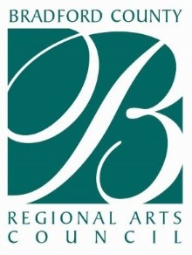
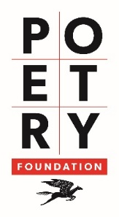
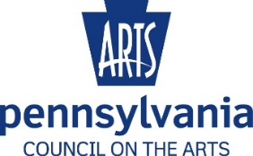
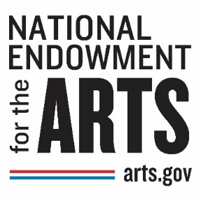
601 Main Street, Towanda, PA 18848
www. bcrac.org

